- A case of diffuse esophageal spasm treated with esophageal myotomy and Belsey Mark IV fundoplication
고대구로병원 이강훈, 김현구
Kanghoon Lee, Hyun Koo Kim, Kook Nam Han, Young Ho Choi
Department of Thoracic and Cardiovascular Surgery, Korea University Kuro Hospital, Korea University College of Medicine
A 70-year-old man was refered to our outpatient department. He had a medical history of chronic kidney disease, diabetes mellitus, hypertension, hyperlipidemia, and old pulmonary tuberculosis. He had presented to a local hospital with a 1-month history of progressive dysphagia, and gastroscopy showed about 1.3cm sized diverticulum at the right side of lower esophagus. Barium swallow examination showed uncoordinated peristalsis with simultaneous contraction of middle and lower esophagus at multiple points(the corkscrew appearance), suggesting diffuse esophageal spasm(DES), and also showed outpouching diverticulum(2.1cm) in right side of lower esophagus at the level of T9-10. High resolution manometry revealed hypercontractile esophagus, outflow obstruction at esophagogastric junction(EGJ), and incomplete bolus clearance in 100%. Due to poor response on medical treatment, single-port VATS diverticulectomy and esophagomyotomy with fundoplication were performed. A 4 cm-sized single incision on left mid-axially line was used because of fundoplication. Esophagomyostomy was limited to inferior border of aortic arch, and Belsey-Mark IV fundoplication was performed. Patient showed immediate symptomatic improvement, and was discharged a week later without any comorbidity. A month later discharge, patient showed no difficulties in swallowing without any other treatment.

- The non-intubated VATS biopsy for the patient with compromised airway due to huge anterior mediastinal mass
삼성서울병원 정재준, 조종호
22세 남자 환자와 31세 여자 환자가 anterior mediastinal mass 로 본원 방문하였습니다. VATS mediastinal mass biopsy 의뢰가 되었습니다. 하지만 이 환자들의 종양은 trachea와 left main bronchus 를 압박하고 있었습니다. 이에 전신마취를 이용한 수술은 위험할 것으로 사료되어 non-intubated VATS biopsy, awake VATS 를 계획하였습니다. ECMO preparation 아래 epidural 마취와 local 마취를 병행하여 흉강경을 이용한 mediastinal biopsy 를 안전하게 시행할 수 있었습니다. VATS mediastinal biopsy는 수술적으로 어렵지는 않습니다. 하지만 이런 huge mass 가 있는 경우 induction 시 airway 확보가 어려운 상황이 발생하고 환자를 잃을 수 있습니다. 이에 앞의 경우와 같은 환자에게서 non-intubated VATS biopsy를 성공적으로 시행한 결과를 보고하고자 합니다.

- Postintubation Subglottic LaryngoTracheal Stenosis and TEF
가톨릭대 성빈센트병원 장용진, 조덕곤
A postintubation tracheoesophageal fistula (TEF) complicated with subglottic laryngotracheal stenosis (SLTS) is a challenge to the thoracic surgeon. Laryngotracheal resection and primary reconstruction could result in treatment failure. In this case, we describe the successful management of postintubation TEF complicated with SLTS
A 68-year-old man presented with dyspnea and cyanosis as chief complaints. The patient was hospitalized for two months at the local clinic with COPD and Status epilecticus. He underwent tracheostomy during hospitalization and discharged after weaning with home O2. On the eighth day after discharge, a tracoe was replaced, and dyspnea and cyanosis subsequently developed. The patient improved after ventilator care. But, every time a patient swallows food, food is drained through the tracoe. The patient was diagnosed with postintubation subglottic laryngotracheal stenosis and tracheoesophageal fistula through preoperative evaluation. The operation was performed jointly with ENT. First, the thoracic surgeon performed the fistulectomy, primary repair of esophagus and tracheal resection, and the otolaryngologist performed the cricotracheal resection & suprahyoid release, end to end anastomosis, augmentation with inferioly based SCM rotation flap immediately. On the 5th day postoperatively, lower tracheostomy was performed with extubation. The patient was discharged home 22 days after surgery with home O2, and is under follow-up.

- Successful esophageal bypass surgery in a patient with a large malignant esophago-pleural fistula following esophageal stenting due ALK-negative lymphoma after pneumonectomy due to lung cancer
신촌세브란스병원 박성용
Seong Yong Park, M.D, Ph.D.
Department of Thoracic and Cardiovascular Surgery, Yonsei University College of Medicine, Seoul, Republic of Korea
Seventy-four years-old female patient admitted due to chronic cough and dysphagia. She received the right pneumonetomy and mediastinal lymph node dissection due toe lung cancer (adenoid cystic carcinoma, pT3N0) at 1997 and she did not receive any adjuvant therapy. On EGD, there was a lesion looks like esophageal SMT with mucosal ulceration at 28-35 from incisor. On pathologic reports, that lesion was an ALK-negative type anaplastic large cell lymphoma which arose from esophagus. The first line CHOP regimen was started at June 2016. Ten days later after first chemotherapy, she suffered from sudden chest pain and chest CT revealed the disruption of lymphoma and related right empyema thoracis. The pig-tail catheter and esophageal stent was inserted but perforation site was not fully covered by stent. Under the status of stent insertion status, second line Brentuximab monotherapy was done 4 times. At December 2016, the mass progressed and esophageal obstruction was done. After the two times of Brentuximab monotherapy, the mass did not increased and she received the conservative treatment only. She had not eaten anything in her mouth for more than one year. Even though the expected survival of anaplastic large cell lymphoma was about one-year, hematologist asked the possibility of esophagectomy and reconstruction. The esophagectomy itself was impossible due to patient’s condition and technical problems which related to the previous pneumonectomy, therefore the esophageal bypass surgery was planned. Esophageal bypass surgery was performed through upper abdominal and neck incisions at October 2017. Under laparotomy, the gastric mobilization was done without sacrificing the left gastric artery. The narrow gastric tube was made and Lembert suture was done. Foley catheter was inserted at the remnant stomach of lesser curvature for draining the gastric juice. The substernal route was made with blunt dissection without interrupting the empyema sac. Cervical esophagus was divided through neck incision. Narrow gastric tube was placed in the substernal route and esophagogastric anastomosis was done with hand-suture. Feeding jejunostomy was made. The patient started oral feeding and discharged at POD 7 without any swallowing problems and complications. The esophagography showed the good passage of contrast dye.

- Correction of reactive pectus carinatum with double-bar insertion
강남세브란스병원 강민균, 이성수
A 6-year old children was admitted to the Department of Caradiothoracic Surgery for the correction of reactive pectus carinatum. He underwent Nuss operation in 2015 for the pectus excavatum. Within 1 year of the correction, a protruding anterior chest deformity resembling pectus carinatum (reactive pectus carinatum) emerged. For the correction of reactive pectus carinatum, we used double-bar insertion technique: the presternal and substernal bars. We made incision on the previous scar and dissected subcutaneous tissues. Then, we removed the previous Nuss bar. Anterior chest wall traction was done with sternal wiring and Kent retractor. First, we inserted two substernal bars: upper and lower bars. For the protection of intrathoracic cavity organs during substernal area dissection, 5mm trocar was inserted through right anterior axillary line 7th intercostal space and thoracoscope was used. After that, we inserted two upper and lower presternal bars. Upper and lower double-bars were fixated respectively. Total 4 bars were utilized: upper double bar and lower double-bar. After JP drain insertion in the thoracic cavity and wound closure, the operation was over. The patient was discharged in stable condition 4 days after the operation. On the first outpatient department visit after discharge, he was in good condition and his parents was satisfied with the result.
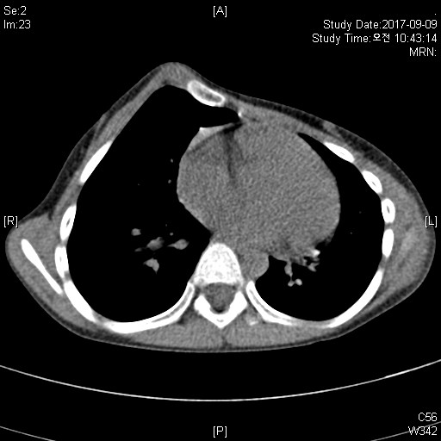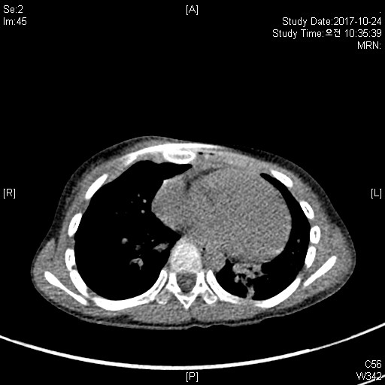
Fig. 1. Computed tomography of the chest shows a correction of reactive pectus carinatum after double-bar insertion.
- IgG4 related disease invading trachea and SVC in mediastinum
계명대학교 동산의료원 채민철, 박창권
Chang Kwon Park, Min Cheol Chae

IgG4-related disease is recently recognized condition with systemic immune mediated disease. It is characterized by tumor like swelling of involved organ, lymphoplasmacytic infiltration of IgG4 positive plasma cell and fibrosis. The most common manifestations are autoimmune pancreatitis, sclerosing cholangitis, parotid and lacrimal gland swelling. Multiple immune mediated mechanism contribute to the fibroinflammatory reaction of disease. Steroid is the first line of therapy. Occasionally immunosuppressive agent and rituximab appears to be useful.
In this case, a 70-year old female patient was admitted to our institute for dyspnea and facial edema. She was medicated with a bronchodilator, regularly given to her due to bronchial asthma. She underwent computed tomography for dyspnea 15 years ago. There was a mediastinal mass in the intratracheal and right lower paratracheal area, she therefore underwent a resection operation through right posterolateral thoracotomy. An irregular solid and partially cystic mass was noted, which was measured to be 4.0 × 5.0 cm around the lower paratrachea and adhered to the SVC and azygos vein. We performed mediastinal mass excision, tracheal resection and end-to-end anastomosis, as well as partial resection and repair of the SVC. Microscopic findings of the mass from the first operation showed diffusely fibrosclerotic change with proliferation of the fibroblasts and infiltration of chronic inflammatory cells. The mass was diagnosed as an inflammatory pseudotumor (plasma cell granuloma) at that time. She took a bronchoscope for dyspnea and hemoptysis 6 years later. There was a smooth polypoid mass at the lower trachea. The mass was again diagnosed as an inflammatory pseudotumor (plasma cell granuloma). In addition, she received LASER treatment. After the LASER treatment, she had been doing well with no specific symptoms, and there was no specific finding on the bronchoscope. However, she repeatedly complained of dyspnea and facial oedema 2 years later. There was no abnormal finding on her laboratory examination. On chest CT examination, there was a 4.7 cm sized enhanced mass in the SVC without obstruction. We performed a resection of the mass for symptom relief through median sternnotomy. The mass was resected, and innominate vein to right atrium auricle bypass was performed. She was relieved of the SVC syndrome and seems to be recovering well. Gross findings of the mass showed it to be relatively well-encapsulated, pale tan and solid, measuring 2.4 × 2.2 × 1.0 cm. Microscopic findings of the mass revealed features similar to the previous tumours, with markedly increased lymphoid follicles, fibrosclerotic change of the stroma and a heavy infiltration of the plasma cells. In addition, immunohistochemical staining for immunoglobulin G4 (IgG4) antibody demonstrated diffusion with strong positivity at the increased plasma cells. The mass was diagnosed as IgG4-related sclerosing disease, according to the histological and immunohistochemical features. The plasma IgG4 level was 0.15 g/l postoperatively.

- Successful diagnosis and treatment of panceaticopleural fistula presenting unusual empyema with hemoptysis
부산대병원 안효영, 김영대
A 43-year-old male alcoholic patient with a history of recurrent episodes of acute pancreatitis was transferred due to unsolved right empyema. A CT scan showed a right pleural effusion and loculated fluid in periesophageal space, suspected infection. Video-assisted decortication and exploration of periesophageal space was performed. Laboratory analysis of the fluid revealed amylase rich exudate. After esophagography confirmed no evidence of leakage, oral feeding was started from POD 2. Chest tube was removed on POD 12 and he was discharged on POD 14. On POD 32, he was readmitted due to hemoptysis. A CT scan showed pneumomediastinum which suggested distal esophago-nodal fistula. Endoscopy and bronchoscopy were followed to be found out no significant causes which developed these symptoms. Since hemoptysis was persisted, bronchial artery embolization was tried, but failed due to no existence of bleeding focus on bronchial artery. Considering with air density in peripancreatic space, MR pancreas was checked on POD 47 which revealed panceaticopleural fistula (PPF). Endoscopic retrograde cholangio-pancreatography (ERCP) was planned to allow for simultaneous assessment of the fistula and for decompression of ducts. After three times of ERCP, hemoptysis was resolved and laboratory blood analysis of amylase was reduced. Herein, we present successful diagnosis and treatment of one patient with PPF who was suffered from unusual presentation of empyema with hemoptysis.

- Right upper pulmonary vein thrombosis clinically mimicking with pulmonary torsion following the right middle lobe lobectomy with anterior segmentectomy of the right upper lobe
동남권원자력의학원 윤유상
Yoo Sang Yoon, Soo Young Jung, Han Ji Hyun, Dongwon Kim
Dongnam Institute of Radiological & Medical Science
Pulmonary vein thrombosis is rare but commonly observed in the metastatic carcinoma, lung transplantation and lobectomy. Few cases of pulmonary vein thrombosis following lung resection have been literally reported. We present our clinical experience of pulmonary vein thrombosis with the gross view, which developed after right middle lobe lobectomy with anterior segmentectomy of right lung in the patient with synchronous double primary adenocarcinomas of right middle and upper lobe. After postoperative 2 days, we had performed completion right upper lobectomy due to remained right upper lobe necross caused by segmental vein thrombosis. After 2nd operatation, the patient had improved uneventfully and discharged at 9 days later.

